**KANTIPUR CITY COLLEGE**

**(Affiliated to Purbanchal University)**

**Putalisadak, Kathmandu**



A project proposal submitted in partial fulfillment of the requirement for the degree of Bachelor in Computer Engineering

**A Project Proposal**

**on**

**“Library Management System”**

**Submitted by**

**Bibhash Raj Budathoki (07BEC2015)**

**Bijay Pathak (08BEC2015)**

**Bishal Shrestha (09BEC2015)**

**Submitted to**

**Department of Computer Engineering**

**May 2018**

**KANTIPUR CITY COLLEGE**

**CERTIFICATE OF APPROVAL**

The undersigned certify that they have read and recommended to the Department of Computer Engineering for acceptance, a project report entitled “Library Management System” submitted by

1. Bibhash Raj Budathoki (07BEC2015)
2. Bijay Pathak (08BEC2015)
3. Bishal Shrestha (09BEC2015)

in partial fulfillment for the degree of Bachelor of Engineering in Computer Engineering.

………………………….....

Subash Raj Karnikar

Supervisor

Kantipur City College

……………………………..

Raju Kattel

Head of Department

Kantipur City College

…………………………….

Bikash Sir

Project Co-ordinator

**Acknowledgement**

This project will be constant part of our academic life for upcoming years. We acknowledge here number of people who have been helpful during this work. First of all we would like to thanks our principal Er. Rabi Shrestha, our project supervisor and our teacher for their kind co-operation with their invaluable suggestions and guidelines. This proposal regarding the partial fulfilment of the requirements for the degree of BE Computer under the Purbanchal University. We acknowledge our deep sense of gratitude to all of them.

I wish to express my special appreciation to all my friends and my seniors for their kind suggestions and co-operations. Above all we especially thankful to our project supervisor for his suggestions and guidelines. Finally we would like to express my sincere gratitude to all that has helped us directly and indirectly in this project.

**Abstract**

Library management system is a project which aims in developing a computerized

system to maintain all the daily work of library. It has a facility of admin login through which the admin can monitor the whole system. It has also a facility where student can see list of books issued and its issue date and return date and also the students can request the librarian to add new books by filling the book request form.The librarian after logging into his account ie admin account can generate various reports such as student report , issue report, teacher report and book report. Overall this project of ours is being developed to help the students as well as staff of library to maintain the library in the best way possible and also reduce the human efforts.

# 1 Introduction

This document provides a detailed design of the system. Please refer to the requirement analysis document and high level design document for the overall view and high level design of the system. This document concentrates on the detailed design of the system, including database connection, programming platform, activities diagrams of whole system and each operation of each class.

## 1.1 Background of the Study

Library management is a sub-discipline of institutional management that focuses on specific issues faced by libraries and library management professionals. Library management encompasses normal management tasks as well as intellectual freedom, anti-censorship, and fundraising tasks. Issues faced in library management frequently overlap those faced in management of non-profit organizations. Library Management System is an application that portraits library system which could be generally small or medium in size. It is used by the librarian to categorically manage the library by the virtue of using a computerized system where he/she can record various transactions like issue of books, return of books, addition of new books, addition of new students etc.

Books and user maintenance modules are also included in this system which would keep track of the users using the library and also a detailed description about the books a library contains. With this computerized system there will be no loss of book record or member record which generally happens when a non-computerized system is used. In addition, report module is also included in Library Management System. If user’s position is admin, the user is able to generate different kinds of reports like lists of users registered, list of books, issue and return reports. All these modules are able to help librarian to manage the library with more convenience and in a more efficient way as compared to library systems which are not computerized.

This system will be developed and designed to help librarian record every book transaction so as to reduce and eradicate problem of loss of books and files in the library.

**1.2** **Statement of the Problem**

Presently, transaction of books in the institutional libraries have been done manually in most cases, thereby taking more time for transaction like borrowing of books or return of books and also searching of member and books. Series of problems occur as a result of this thereby resulting to inefficient library management. In most cases as a result of human error there maybe loss and damages of records due to not using a computerized system in the library.

Nevertheless, the difficulty in the searching of books which could be termed to be inadequacy in book Management is a problem in the manual library thereby causing inefficiency and time consuming in the library. Also the problem of space consuming erupts after the number of records become large the space for physical storage of file and records also increases if no computerized system is implemented as well as the issue of cost. Due to problem of lack of prompt information retrieval and time wastage in using the library. In addition due to the cumbersome, in this project computer approach will be used to solve these problems. Each of the manual procedure will be analysed.

**1.3** **Aim and Objectives**

The aim of this project is to develop a system that can handle and manage the activities involved in a library in an efficient and reliable way.

The objectives are:

1. Designing a computerized library management system which would help evacuate the problem faced in manual library.
2. Evaluating and testing the performance of the system.
3. Implementing the system using barcode technology.

**1.4** **Purpose of the Project**

The main purpose of this project is to develop a computerized system that will manage the activities in the library thereby providing easy access of library usage for librarian and users of the library, it will also help librarians keep track of library information etc. This system will also provide electronic means of storage and help librarians keep track of library information. This system will be implemented using barcode to make the issuing and returning books easier and faster.

**1.5** **Scope of the Project**

The project product to be produced is a Library Management System which will automate the major library operations. The first subsystem is the registration of the users to the system to keep track of authorized users to the system. The second subsystem is the registration of new books into the library management system to know when new books are brought into the library. The third subsystem is a borrower and return of books which is the major area needed by the user.

There are three end users for the Library Management System. The end users are the admin, users and members.

**2.0** **LITERATURE REVIEW**

**2.1** **Introduction**

Library is regarded as the brain of any institutes, of course many institute understand the importance of the library to the growth of the institute and their esteem users which we categorically call the students. Anintegrated library system, also known as a library management system (Adamson et al., 2008) is an enterprise resource planning system for a library, used to track items owned, orders made, bills paid, and users who have borrowed.

The Library Management System is a Library Management software for monitoring and controlling the transactions in a library (Ashutosh and Ashish., 2012). Library Management System supports the general requirement of the library such as the acquisition, cataloguing, circulation and other sections.

Before the advent of computer in modern age there are different methods of keeping records in the library. Records are kept in the library on shelves and each shelf are labelled in an alphabetical or numerical order, in which the categories of books available are arranged on different position on the shelves and as well are recorded on the library manuscript and when any book is to be referenced the manuscript is being referred to, to know the position of such required book by the person that requested for the book.After the invention of computer different researchers have carried out various approach on an automated library management system in which this project is as well all about.

The first library management system to be reviewed is the KOHA library management system. Since the original implementation in 1999, KOHA functionality has been adopted by thousands of libraries worldwide, each adding features and functions, deepening the capability of the system. With the 3.0 release in 2005, and the integration of the powerful Zebra indexing engine, KOHA became a viable, scalable solution for libraries of all kinds. LibLime KOHA is built on this foundation. With its advanced feature set, LibLime KOHA is the most functionally advanced open source Integrated Library System in the market today. The major setback of this Library Management System is that it is a web based and as a result it is not security conscious because hackers could have the database hacked and access or modify the information of such user. ([www.koha.org](http://www.koha.org/)).

As for this research, the main purpose of literature review will be to grasp comprehensive ideas on the extent of library management system initiatives and projects that had taken place worldwide and the factors and conditions that had influenced and contributed to their success. The approach to literature review is the browse method where print and electronic sources were looked at, read and digested, looking for some relevancy, appropriateness and usefulness of the topic at hand.

**2.2** **Features of library management**

1. Manage Book and Member Record with help of Barcode.
2. Circulation:Library Management Software enables the complete management of multiple Item issue and return of books using Manual or Barcode Scanner.
3. Barcode:Use of Bar Codes for Library Management eases the everyday tasks of big Libraries, where the No. of transactions exceed several thousands in number.

Moreover, the software can work even without Bar Codes seamlessly. The Bar-Code generation and printing process is a Built-In feature of this Software.

1. OPAC:Library management software admin/Member can easily search book author, Title, Accession No, Publication, and Language also admin can filter data with category wise.
2. Facility for User to suggest items:User suggestion and request for purchasing a new item is handled by the software itself reducing the administrator’s task.
3. Alert through Email:Admin can send mail to members, vendors, or any other people from the software.
4. Powerful Search Engine

ix. Custom Field Indices:Library Software provides sorted data on required fields by clicking on the column header that is if clicked on publisher the data will be sorted on publisher.

x. Lock System:Lock the subject or group of the member, so that media can't be issued which falls under this criteria. One can in this way restrict the issuing of the media.

xi. Auto Filter & Auto Search: On each master form, Library Software will search on the field where your cursor is and what you type is taken as a search value.

xii. A student’s name typed while issueing will reveal his semester and his subjects to admin which will make easier to issue book.

xiii. Reports

**2.4** **Needs for library management system**

From the literature review we have found the following needs for the Library Management System

1. Improved services through greater access to accurate information
2. Increased productivity and job satisfaction among staff members as it eliminates duplication of effort
3. More economical and safer means of storing and keeping of information
4. Easier access to information like management reports and stock etc. as well as accurate and faster results from statistical analyses.
5. Reduces errors and eliminating of ennui of long and repetitive manual processing
6. Greater accountability and transparency in operations
7. Improved efficiency and effectiveness in administration and management as it has unprecedented access to real- time information.
8. More reliable security for sensitive and confidential information.

**3.0** **SYSTEM ANALYSIS AND DESIGN**

**3.1** **Introduction**

To develop a best fit system to the library, there are three stages of developing the new system. They are gather information, design and implementation and final testing. Within these three sections, different tactics will be adopted so that we can design a system that can maintain high usability and accessibility. Below are some ideas to the process

**3.2** **Information Gathering**

Before setting up the system by software development tools, information will be gathered from the staff about the need for the users of the system like the staff of library and those readers by using qualitative gathering techniques (oral interviews). Before starting to implement the system, interviews will be made to get readers view on the system before having the design works being done. After considering the scope and the objectives of this study, it is very much ideal to use the qualitative gathering techniques method i.e. the survey method, using the oral interview.

Interviews would be done to investigate and identify the scenario that libraries were going through in embarking on automation projects having embraced library automation.

The library is a major means of data gathering and as well a case study for the proposed system. In line with this the major method of information gathering for the system is the library and observation method via observing the staff and operation of the library.

**3.3** **Analysis of Existing System**

The existing system of library management system involves lots and lots of paper work. The system involves that all library user details will be taken on a white and black method. To borrow book from a library a borrower information is being taken for every registered user and details are written in a paper everytime book is issued and returned.

**3.3.1 Problems of existing system**

Having have the overview knowledge of the existing system, the following are its problem

1. Loss of Data: A lot of paper works are needed for the safe keeping of the details of books borrowed by a registered user.
2. Time Wasting: User time are wasted as a result of searching for a book that has been borrowed by a user whose record cannot be traced on the paper records.
3. Error Prone: The existing system of operation is prone to error.
4. Tedious: It is tedious because it must take a routine
5. Processing Speed: The processing speed is very low resulting into low output.

**3.3.2 Description of Proposed system**

The library management system is a web based application system used by an administrator (Librarian) as an alternative means of record keeping of the books stored in the library. It has the following features.

1. The administrator registers the applicant with their name as the first and last name, matriculation number, department etc. and a username is being suggested by the user alongside a login password which is to be used for log in by the registered user
2. An applicant is allowed check into the system with his name and email which is given at the point of registration.
3. The administrator goes into the report to view the details of a particular user.

**3.3.3 Advantages of Proposed system**

Certain merits have been associated with the proposed system which enhances the design of the system. Some of which are stated below:

1. It is free from biasness (all users are served equally).
2. It provides an immediate form of response to every user.
3. It facilitates easy learning.

iv. Faster and easier management system.

**3.4** **Design and Implementation Methodology**

The design methodology used in the proposed system is parallel as a result of the fact that parallel methods support the use of the proposed system side by side with the existing system

in order to test for the system efficiency. Top down approach is used as well in the design because it allows the analysis of the system to be carried out one after the other.

In this stage, the first goal will be decided by task analysis. Next, the prototype of the system will be analysed. Then test will be made on its usability and design with some design theories. Thus the prototype will be correspondingly looked at. Then a more complete prototype will be tested by potential users to collect feedbacks. Finally, the system will be finalized with the amendment on some problems of the user interface.

**3.4.1 Software Requirements**

Development tools and Programming language- HTML is used to write the whole code and develop webpages with cascading style sheet, java script for styling work and Django (python-framework for web application) for sever side scripting.

**3.4.2 Software tools used**

The whole Project is divided in two parts the front end and the back end.

**FRONT END:** The front end is designed using of HTML, PHP, CSS, Java script

1. HTML- HTML or Hyper Text Mark-up Language is the main mark-up language for creating web pages and other information that can be displayed in a web

browser. HTML is written in the form of HTML elements consisting of tags enclosed in angle brackets (like <html>), within the web page content.

The purpose of a web browser is to read HTML documents and compose them into visible or audible web pages. It provides a means to create structured documents by denoting structural semantics for text such as headings, paragraphs, lists, links, quotes and other items. It can embed scripts written in languages such as JavaScript which affect the behaviour of HTML web pages.

1. CSS- Cascading Style Sheets (CSS) is a style sheet language used for describing the look and formatting of a document written in a mark-up language. While most often used to style web pages and interfaces written in HTML and XHTML, the language can be applied to any kind of XML document, including plain XML, SVG and XUL. CSS is a cornerstone specification of the web and almost all web pages use CSS style sheets to describe their presentation.CSS is designed primarily to enable the separation of document content from document presentation, including elements such as the layout, colours, and fonts.

This separation can improve content accessibility, provide more flexibility and control in the specification of presentation characteristics, enable multiple pages to share formatting, and reduce complexity and repetition in the structural content (such as by allowing for table less web design).CSS can also allow the same mark-up page to be presented in different styles for different rendering methods, such as on-screen, in print, by voice (when read out by a speech-based browser or screen reader) and on Braille-based, tactile devices. It can also be used to allow the web page to display differently depending on the screen size or device on which it is being viewed.

1. JAVA SCRIPT- JavaScript (JS) is a dynamic computer programming language. It is most commonly used as part of web browsers, whose implementations allow client-side scripts to interact with the user, control the browser, communicate asynchronously, and alter the document content that is displayed. It is also being used in server-side programming, game development and the creation of desktop and mobile applications. JavaScript is a prototype-based scripting language with dynamic typing and has first- class functions. Its syntax was influenced by C. JavaScript copies many names and naming conventions from Java, but the two languages are otherwise unrelated and have very different semantics.The key design principles within JavaScript are taken from the self and Scheme programming languages. It is a multi-paradigm language, supporting object-oriented, imperative, and functional programming styles.

**BACK END-** The back end is designed using Django and SQLite which are used to perform server side scripting and as a database respectively.

1. **Django** is a high-level Python Web framework that encourages rapid development and clean, pragmatic design. Built by experienced developers, it takes care of much of the hassle of Web development, so you can focus on writing your app without needing to reinvent the wheel. It’s free and open source.

Django's primary goal is to ease the creation of complex, database-driven websites. Django emphasizes reusability and "pluggability" of components, less code, low coupling, rapid development, and the principle of don't repeat yourself (DRY). Python is used throughout, even for settings files and data models. Django also provides an optional administrative create, read, update and delete interface that is generated dynamically through introspection and configured via admin models.

Some well-known sites that use Django include the Public Broadcasting Service, Instagram, Mozilla, *The Washington Times*, Disqus, Bitbucket, and Nextdoor. It was used on Pinterest but later the site moved to a framework built over Flask.

1. **SQLite** is a relational database management system contained in a C programming library. In contrast to many other database management systems, SQLite is not a client–server database engine. Rather, it is embedded into the end program.

SQLite is ACID-compliant and implements most of the SQL standard, using a dynamically and weakly typed SQL syntax that does not guarantee the domain integrity.

SQLite is a popular choice as embedded database software for local/client storage in application software such as web browsers. It is arguably the most widely deployed database engine, as it is used today by several widespread browsers, operating systems, and embedded systems (such as mobile phones), among others. SQLite has bindings to many programming languages.

**3.5** **System Development Approach**

System development life cycle is referred to a methodology for developing systems. It produces a consistent frame work of tasks and deliverables needed to develop systems. The SDLC methodology may be condensed to include automated or manual, whether it is a new system, or an enhancement to existing system. The SDLC methodology tracks a project from an idea developed by the user through feasibility study, systems analysis and design, programming , pilot testing, implementation and post implementation analysis,

System development life cycle means combination of various activities. In other words various activities put together are referred to as system development life cycle. In the system analysis and design terminology system development life cycle is known to be software development life cycle, the following are the different phases of software development life cycle.

Software concept, Requirement analysis, Architectural design, Coding and debugging, System testing, Implementation, Maintenance.

**3.5.1** **Architectural design**

The phase of the design of computer architecture and software architecture can also be referred to as high-level design. The baseline in selecting the architecture is that it should realize all which typically consists of the list of modules, brief functionality of each module, their interface relationships, dependencies, database tables, architecture diagrams, technology details etc. The integration testing design is carried out in the particular phase. After the requirements have been determined the necessary specifications for the hardware, software and people and data resources and the information products that will satisfy the functional requirement of the proposed system can be determined. The design will serve as a blueprint for the system before these errors or problems are built into the system.

**3.5.2 Module design**

The module design phase can also be referred to as low-level design. The designed system is broken up into smaller units or modules and each of them is explained so that the programmer can start coding directly. The low level design document or program specifications will contain a detailed functional logic of the module in pseudo code:

1. Database tables, with all elements, including their type and size.
2. All interface details with complete API references.
3. All dependency issues.
4. Error message listings.
5. Complete input and outputs for a module.

The unit test design is developed in this stage.

**3.6 Database Design**

**Tables**

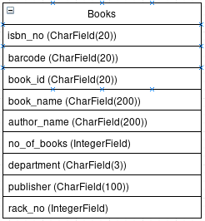

Fig: Book Table

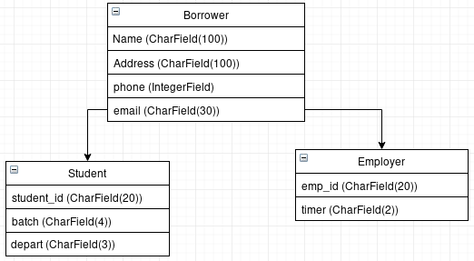 Fig: Borrower table

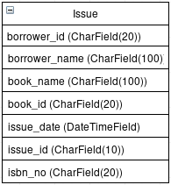

Fig: Issue Table

**3.7 Data Flow Diagram**

**3.7.1 Context Diagram**

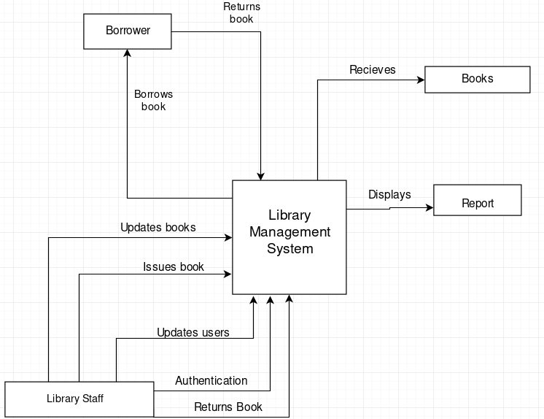

**3.7.2 Level 1 Diagram**

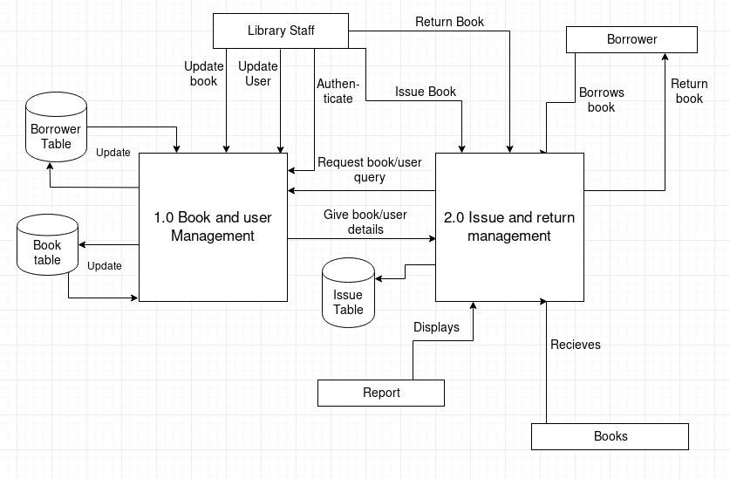

**3.8 ER Diagram**

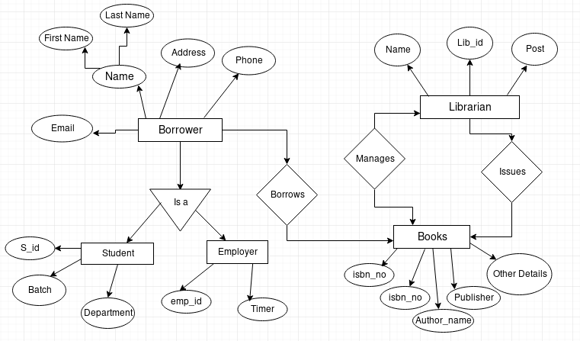

**4.1** **Implementation of the System**

This describes how the system works and how best computers together with other resources may be applied to perform data storage, management and retrieval for decision making. The requirement of this research work demand a web programming language.

**4.2** **Hardware Support**

The hardware that is required in the successful completion of this project include;

1. A system running on Pentium 5 or latest.
2. A random access memory (RAM) of 1GB or more.
3. Enhanced Keyboard.
4. V.G.A or a coloured monitor.

v. Well functioning Barcode Scanner

**4.3** **Software Support**

The software support for the design of the proposed system involves:

1. Any 32 bit or 64 bit operating system
2. Django Installed on the computer
3. **An internet access (intranet or internet) for server.**

**4.4 Designs of the project**

This section includes the implementation of the above mentioned protocals and the snapshots of the project in localhost:8000 port.

**Home page or dashboard.**

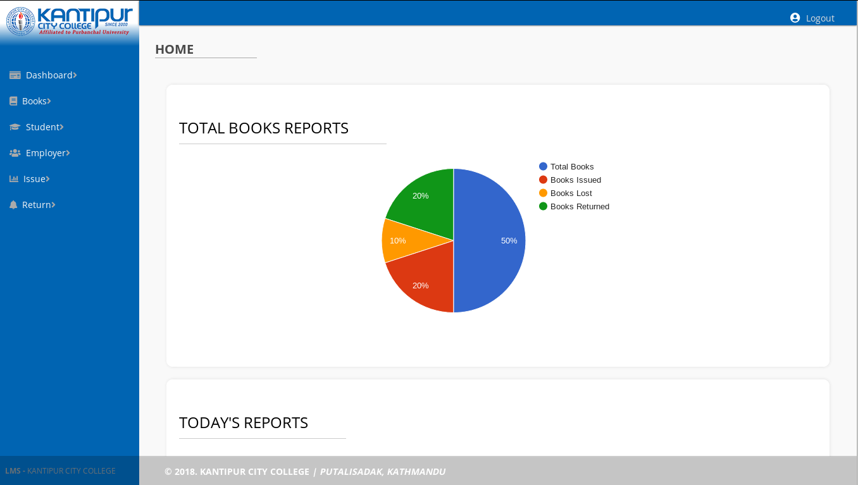

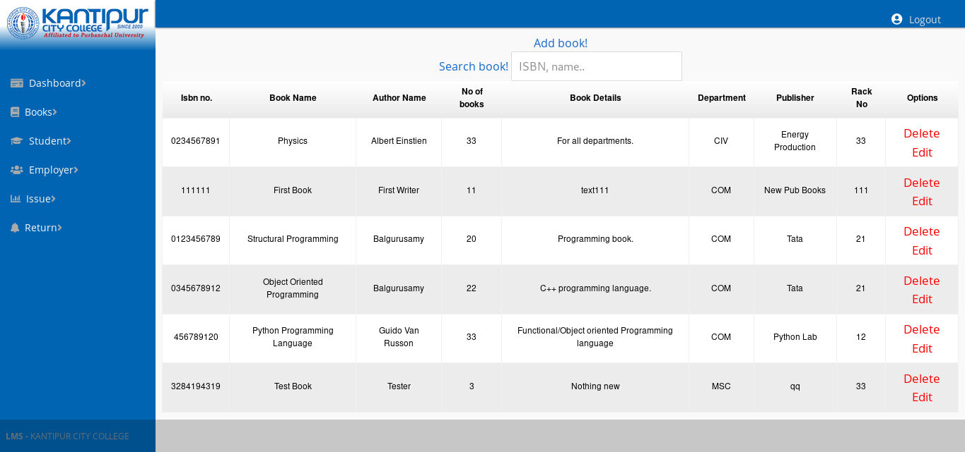

**View Book page**

**Add Book Page**

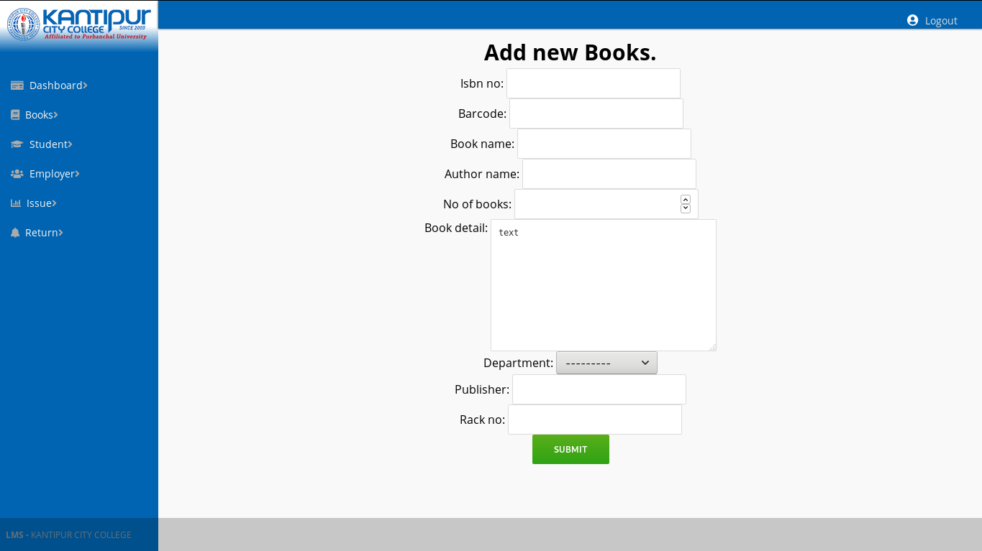

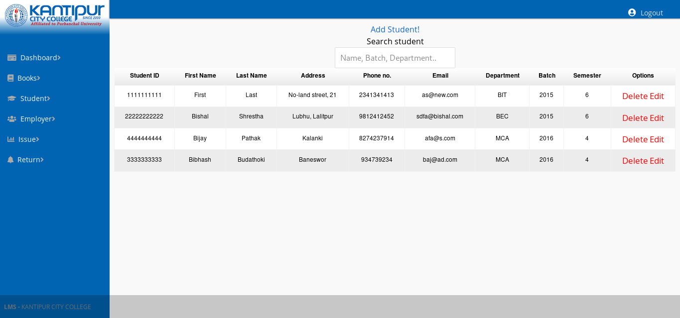**View Students**

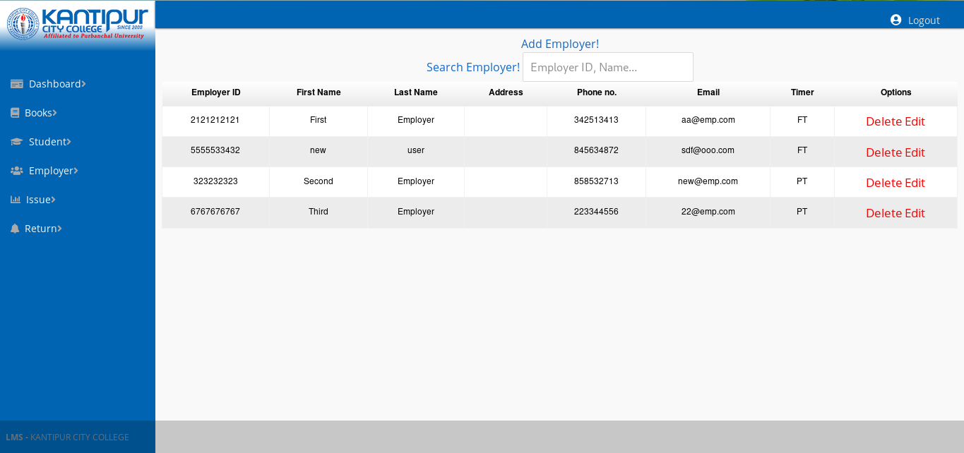**View Employer Page**

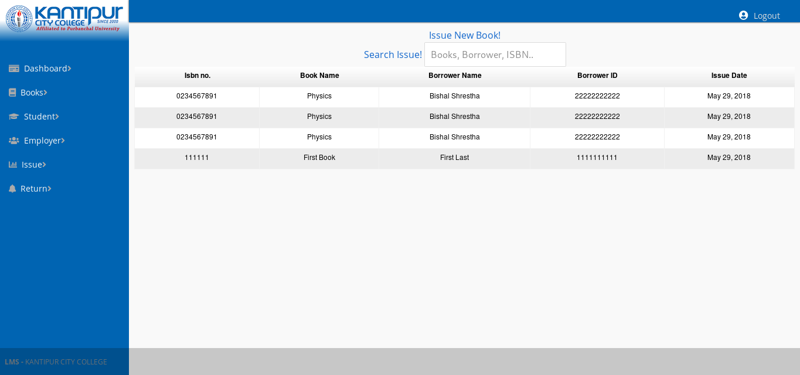**View Issue Page**

**Return Page**

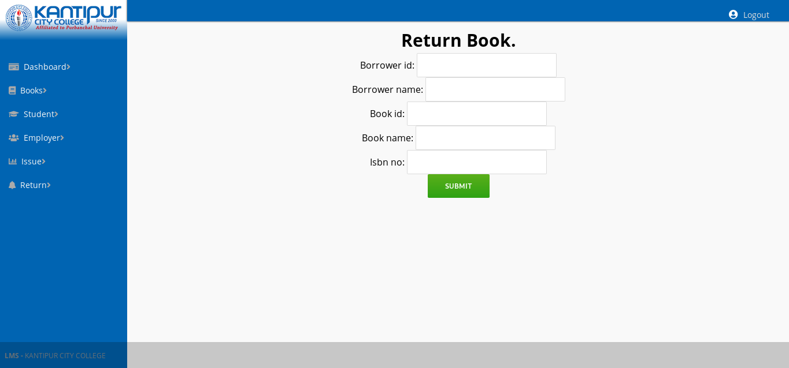

**Gnatt Chart**



|  |  |
| --- | --- |
| **Tasks Completed** |  |
| **Tasks Remaining** |  |

TOTAL WEEKS: 8

**5.0** **SUMMARY, CONCLUSION AND RECOMMENDATION**

**5.1** **Summary**

The quest to make life easier and processing faster has led to computerization of various processes. Computer technology has transformed so many sectors especially the Educational sector in no small measure. In an effort to foster technology driven education, a Library Management System has been developed to manage all library operations such as borrowing, returning of books etc.

**5.2** **Conclusion**

In conclusion, from proper analysis and assessment of the designed system it can be safely concluded that the system is an efficient, usable and reliable Library Management System. It is working properly and adequately meets the minimum expectations that were for it initially. The new system is expected to give benefits to the users and staff in terms of efficiency in the usage of library system

**5.3** **Recommendation**

For further research work to be carried out. I hereby suggest the following

1. University Library should be developed to work on any platform.
2. Diagrammatic representation as a lecturing aid should be included in a UniversityLibrary.
3. University library lecturing should also be extended to other field of study such as chemistry, English Biology Agricultural science and many others.

iv. University library should be developed to support audio, video and a diagrammatic **aid to learning.**

**REFERENCES**

Siwakoti, S. (2008). Status of school library development in Nepal. Sri Lanka Journal of Librarianship & Information Management, Vol.1 (1), pp.13-19. Available:

http://www.cmb.ac.lk/academic/institutes/nilis/reports/Nepal.pdf.

First Online Library (1999). Koha

http://www.koha.org

Data Flow Diagrams and Gnatt Chart

https://www.draw.io